Differential Amplifier HW (19 points)
(jas, Differential Amplifier HW.docx, 12/8/2025)

Clearly indicate answers and include units for numeric answers, using 3 or 4 significant figures. Show at least the major steps of your work so that if necessary partial credit can be awarded.
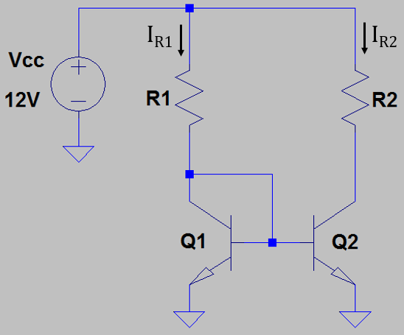
- For the adjacent current-mirror circuit, given that Q1 and Q2 are matched transistors operating in the active region, calculate the value of R1 necessary to set the mirrored current, i.e. I_{R2}, to 100 µA. (Hint: R1 should be somewhere between 100 and 120 kΩ.) (2 points.)
$$R1=\frac{12V-0.7V}{100μA}=113kΩ$$
$$R1=113kΩ$$

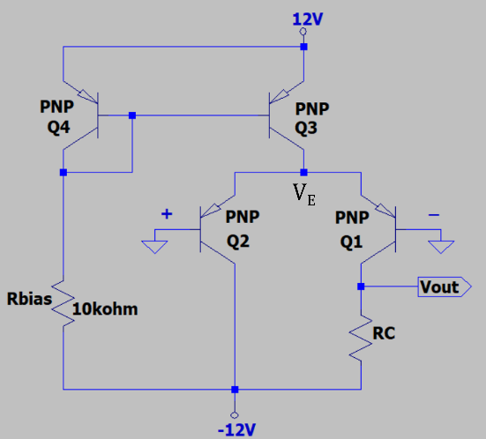
- For the adjacent differential amplifier, determine the following, given that Q1 – Q4 are matched transistors operating in the active region. (Hint: I_{Q1} should be somewhere between 1.0 and 1.2 mA.) (3 points total.)

- V_{E}. (1 Point.)
$$V_{E}=V_{BE}=-0.7V$$
$$V_{E}=-0.7V$$
- I_{Q1}. (2 Points.)
$$I_{Q4}=\frac{11.93V--12}{10kΩ}=2.393mA=I_{Q3}$$
$$I_{Q1}=\frac{I_{Q3}}{2}=1.1965mA$$
$$I_{Q1}=1.1965mA$$

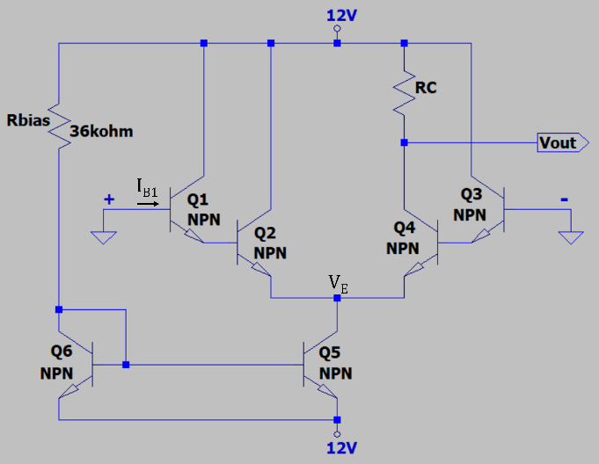
- For the adjacent differential amplifier with β = 150 for all transistors, determine the following, given that Q1 – Q6 are matched transistors operating in the active region. (Hint: I_{B1} should be somewhere between 10 and 20 nA.) (5 points total.)

- V_{E}. (1 Point.)
$$V_{E}=0.7V+0.7V=1.4V$$
$$V_{E}=1.4V$$

- I_{Q5}. (2 Points.)
$$I_{Q6}=\frac{12--11.3}{36kΩ}=647μA=I_{Q5}$$
$$I_{Q5}=647μA$$

- I_{B1}. (2 Points.)
$$I_{B1}=\frac{I_{CQ5}}{2β^{2}}=\frac{647μA}{2*{150}^{2}}=14.38nA$$
$$I_{B1}=14.38nA$$

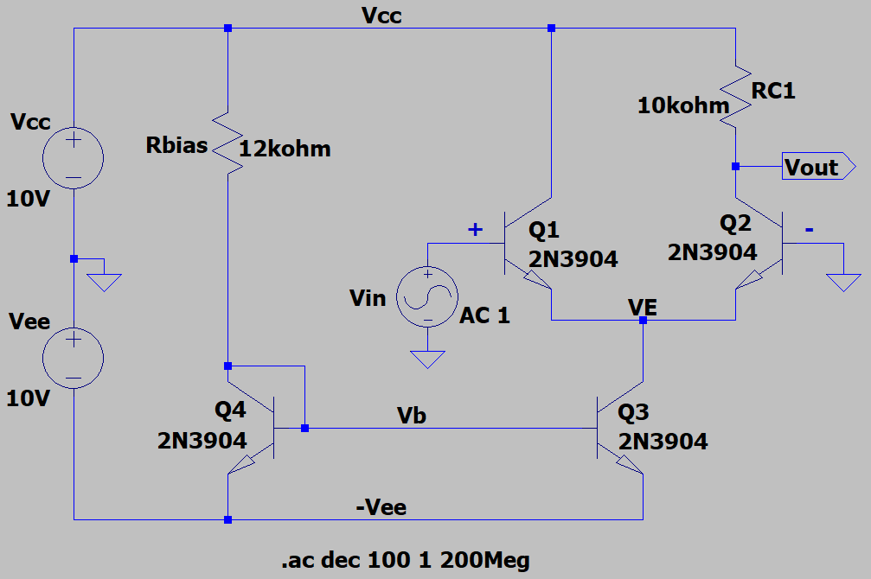
- For the adjacent differential amplifier, determine the following for R_{L} = ∞, given that Q1 - Q4 are matched transistors operating in the active region. (Hint: A_{V_dB} should be somewhere between 40 and 46 dB.) (6 points total.)

- I_{Q3}. (2 Points.)
$$\frac{10V--9.3V}{12kΩ}=1.608mA=I_{Q3}$$
$$I_{Q3}=1.608mA$$

- I_{Q2}. (1 Point.)
$$I_{Q2}=\frac{I_{Q3}}{2}=804μA$$
$$I_{Q2}=804μA$$

- $r_{e2}^{'}$. (1 Point.)
$$r_{e2}^{'}=\frac{25mV}{804μA}=31.09Ω$$
$$r_{e2}^{'}=31.09Ω$$

- A_{V_dB}. (2 Points.)
$$A_{v}=\frac{RC}{2r_{e}^{'}}=\frac{10kΩ}{2\left(31.09Ω\right)}=160.83$$
$$A_{v_dB}=20\log\left(160.83\right)=44.13dB$$
$$A_{v_dB}=44.13dB$$

- Determine the open-loop gain of a differential amplifier with a common-mode rejection ratio of 86 dB and a common-mode gain of $30 x {10}^{-3}$. (Hint: $A_{V}$ should be somewhere between 550 and 650.) (3 points.)
$$CMRR_{dB}=20\log{\frac{A_{V}}{A_{CM}}}$$
$$A_{V}={10}^{\frac{CMRR_{dB}}{20}}*A_{CM}={20}^{\frac{86}{20}}*30*{10}^{-3}=598.58$$
$$A_{V}=598.58$$

